**Manitoba Renal Technology**  
  
Web Development - Design Document

**

**Table of Contents**

Design Document Introduction 3

Requirements Definition – section 1 4

Current Requirements – section 1.1 4

Long Term Requirements – section 1.2 4

User Experience – section 2 5

Audience Definition – section 2.1 5

Competitive Analysis – section 2.2 5

Competitive Analysis for St. Michael’s Hospital Renal Technology 6

Competitive Analysis for Fresenius Medical 7

Competitive Analysis for NxStage Medical 7

# Design Document Introduction

The Renal Technology Department of the Manitoba Renal Program supports machines, devices and infrastructure related to dialysis in Manitoba and northwest Ontario. The territory includes support for sites in areas such as Winkler, Swan River, Thompson, Kenora and remote sites such as Garden Hill and Cross Lake. Dialysis equipment is situated in both local health facilities and within patients’ homes.

Supporting the technology at the health facilities and patient homes is logistically challenging and traveling to the various sites is often required. The website will act to mitigate these challenges and increase support for all the people involved with Manitoba renal technology.

The Renal Technology Department has recognized that a web presence would be valuable to home patients, health facility staff, and technicians. A website would provide the necessary manuals and documentation needed to efficiently service and maintain dialysis equipment throughout the territory.  
  
The Renal Technology Department has selected SixYooz Media to develop the web site. To help ensure the requirements of the web site are achieved, SixYooz will produce a detailed Design Document that will log all of the development phases and become a record of all decisions made during the project.  
  
The following individuals will be responsible for the development of the site:

|  |  |
| --- | --- |
| **SixYooz Media** |  |
| Brian Hodgert | Web Project Manager |
| Brian Hodgert | Web Programming and Development |
| Brian Hodgert | Graphic Design |

|  |  |
| --- | --- |
| **Renal Technology Department** |  |
| Doug Franklin | Manager of Renal Technology – Authority to sign off |
| Victor Garcia | Supervisor of Technicians |
| TBD | Home Care Nurse |

# Requirements Definition – section 1

## Current Requirements – section 1.1

**The Renal Technology site will provide support and information to home patients and health facility staff.** Home patients and health facility staff will be able to get important information such as contacts, common problems, and FAQ's.

**The Renal Technology site will provide all manuals currently available in pdf format for viewing.**

Users will be able to download and/or view manuals and support documentation related to the specific equipment they are using or servicing.

**The Renal Technology site will generate work orders from clients and facilities.**

Clients and facilities within the territory will be able to make work orders and service requests for equipment that they use or manage.

## Long Term Requirements – section 1.2

## **The Renal Technology site will access existing databases to query equipment and client information.**

Technicians will be able to view data stored on existing databases to view device specific information such as work orders and contact information maintained by the database administrator.

**The Renal Technology Site will allow entry of Service and Performance Maintenance information.**

Technicians will be able to enter what they did relating to the specific work order or maintenance request. These entries will update information maintained in the database.

**The Renal Technology Site will allow Technologists, Clients and Facilities the ability to view the work history on their equipment.**

Clients and facilities will be able to check the work and maintenance history of their equipment and any pending repairs or maintenance.

# User Experience – section 2

## Audience Definition – section 2.1

**The Audience will be specific and access will involve logins for some of the pages**

The audiences listed below will each have specific access and requirements for viewing. The primary purpose is to provide information that is needed for the efficient and reliable operation of the equipment and infrastructure.

**Technicians**

Technicians will be mostly looking for information they need to service and maintain the equipment.

**Clients (home patients)**

Clients will be looking for simple troubleshooting procedures and contact information to have their equipment serviced. Many will have health issues (mobility, sight) that must be considered when designing the site.

**Health Facility Staff (Staff)**

Nurses and ward managers will be checking on the status of equipment that is in need of service.

## Competitive Analysis – section 2.2

The Renal Technology Department does not directly compete with other service providers but we will be looking at a few sites from which we can draw some inspiration. For this analysis we will look at three sites that provide similar service to The Manitoba Renal Technology department. The first is very basic while the next two have features which are beyond the scope of this project. However, we will still draw certain features from these two sites.

### St. Michael’s Hospital Renal Technology

<http://www.stmichaelshospital.com/programs/renaltechnology/index.php>

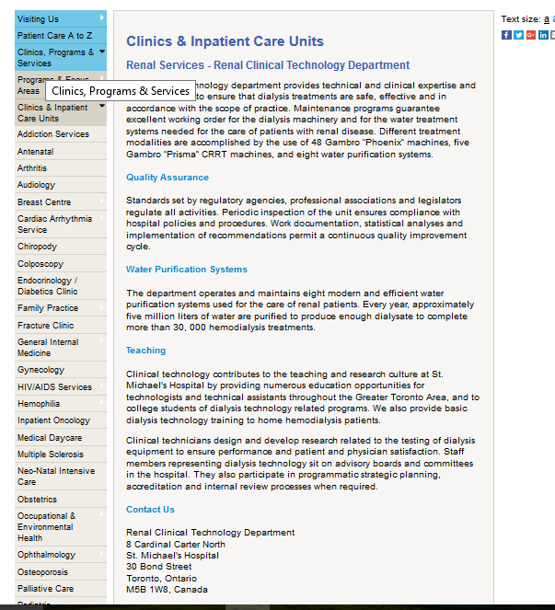

This site shows one of the few pages dedicated to Renal Technology in Canada. As we can see, it is limited in the information it provides to the user.

The intent of the page is to assure users that standards and quality are part of the Renal Technology program.

Information that a user might want, such as what to do when problems happen, are not provided.

The page is also deep within the main site and a user would most likely not be able to navigate to this page.

Very little could be used from this site from a design aspect but some content could be valuable.

### Fresenius Medical Product Support

http://fmcna.com/product-support-services/

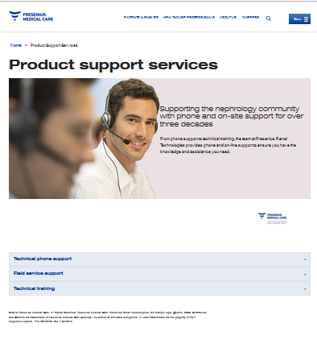

The Fresenius site is a much more informative site and the one from which most inspiration will be drawn.

The site uses a re-sizing menu with nav icon that adjusts depending on the screen size. This makes it comfortable to view on various screen sizes. The top menu is also pinned to the top so one doesn’t have to scroll to navigate.

The design elements are effective and locating information is intuitive.

The main image, however, uses up a lot of screen real estate and could be decreased to make room for content.

### NxStage Support

http://www.nxstage.com/support/

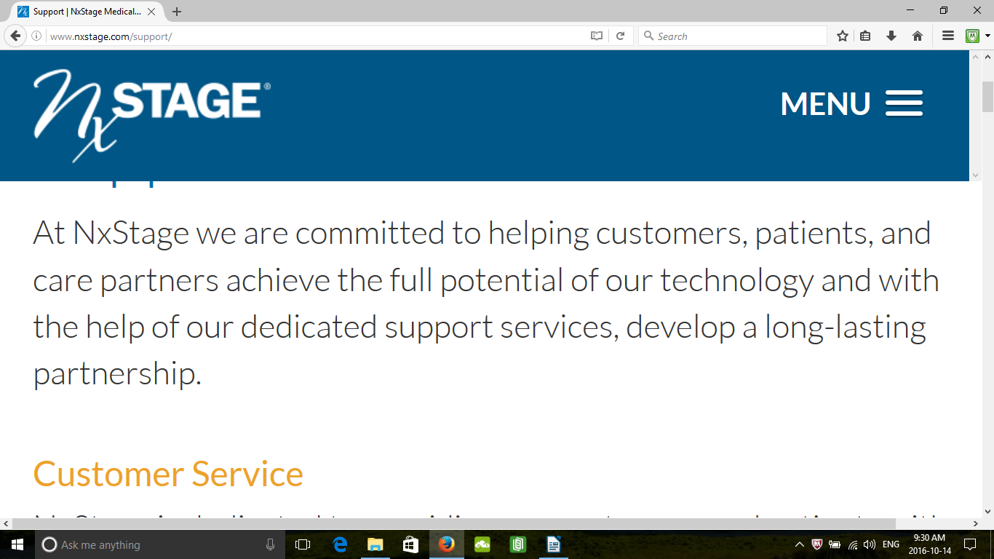The NxStage site is similar to the Fresenius site in its use of re-sizing and the nav icon (shown right of MENU). The screen shots shows the how the layout adjusts to screen sizes. This will be a desirable feature for our site.

This site doesn’t offer manuals but instead relies on a “Contact Us” page for support.

The font used is a little tall and thin making it slightly difficult to read.

